1. Introduction
The contemporary labor market is characterized by rapid structural changes driven by technological advancement, digital transformation, globalization, and evolving organizational requirements. As industries increasingly adopt data-driven decision-making, the importance of understanding workforce behavior, compensation expectations, and professional mobility has grown substantially. For organizations, recruiters, and policymakers, the ability to analyze and interpret large-scale employment data has become a strategic necessity rather than an operational luxury.
Salary expectations represent one of the most critical dimensions of job seeker behavior. These expectations are influenced by a complex interplay of factors such as professional experience, educational attainment, skill composition, industry exposure, geographic location, and current compensation levels. Inaccurate assessment of these expectations can result in inefficient recruitment processes, misaligned compensation structures, and increased attrition rates. Consequently, there is a growing need to employ analytical techniques that can systematically evaluate these factors and uncover meaningful patterns within employment data.
Business Analytics provides a structured framework for extracting insights from large and complex datasets. Through the application of statistical analysis, data visualization, clustering techniques, and predictive modelling, Business Analytics enables organizations to move beyond intuition-based decision-making toward evidence-based workforce strategies. In the context of human resource analytics, such techniques facilitate a deeper understanding of labor market dynamics, candidate segmentation, and compensation determinants.
This report presents an extensive Business Analytics study based on a large-scale Job Seekers dataset containing 913,384 observations. The dataset encompasses a wide range of attributes related to job seekers, including expected salary, current salary, years of work experience, highest level of education, area of specialization, key skills, industry affiliation, city of residence, and preferred job location. The breadth and depth of this dataset provide a robust foundation for analyzing employment trends across multiple dimensions.
The analysis is structured around three core analytical components. First, Exploratory Data Analysis (EDA) is conducted to examine data quality, distributions, central tendencies, outliers, and preliminary relationships among variables. EDA serves as a critical foundation for identifying patterns and informing subsequent modeling decisions. Second, Clustering Analysis is employed to segment job seekers into homogeneous groups based on shared characteristics, thereby enabling a deeper understanding of distinct candidate profiles. Third, Regression Analysis is applied to evaluate the extent to which experience, education, and skills explain variations in expected salary, and to assess the predictive strength of these variables.
The primary objective of this study is to derive meaningful, data-driven insights that contribute to a better understanding of salary expectations and job seeker behavior. By integrating descriptive, diagnostic, and predictive analytics, the report aims to demonstrate the practical application of Business Analytics concepts in a real-world employment context. The findings of this analysis are expected to be relevant not only for academic evaluation but also for organizations seeking to improve recruitment effectiveness, compensation planning, and workforce strategy.

2. Questions Selected
The selection of analytical questions forms the foundation of any data-driven study, as it determines the direction, scope, and relevance of the analysis. In the context of this Business Analytics project, the questions have been carefully formulated to address both descriptive and analytical aspects of job seeker behaviour. Given the scale and richness of the dataset, the selected questions aim to capture salary dynamics, professional characteristics, and labour market trends in a structured and systematic manner.
The first question focuses on understanding the demographic and professional composition of job seekers represented in the dataset. This includes examining variables such as work experience, education level, specialization, skills, industry affiliation, and geographic distribution. Analysing these characteristics provides essential context and enables a holistic understanding of the workforce profile under consideration. Without this foundational understanding, subsequent analytical findings would lack interpretative depth.
The second question examines how salary expectations are distributed across different dimensions, including experience levels, education categories, skills, and cities. Salary expectations are not uniform and often exhibit significant variation due to individual and market-specific factors. By analyzing salary distributions and identifying patterns of skewness or dispersion, the study aims to highlight inequality in compensation expectations and assess how these expectations differ across various subgroups within the workforce.
The third question investigates the relationship between expected salary and key explanatory variables, such as work experience, current salary, education, and skills. Understanding these relationships is essential for identifying which factors have meaningful influence on salary expectations. This question is addressed through correlation analysis and forms the basis for subsequent predictive modelling.
The fourth question explores whether job seekers can be meaningfully segmented into distinct groups based on their professional and compensation-related attributes. Clustering analysis is employed to determine whether natural groupings exist within the data and to identify common characteristics within each segment. This segmentation is particularly useful for recruiters and organizations seeking to tailor hiring strategies to different candidate profiles.
The fifth question evaluates the predictive capability of experience, education, and skills with respect to expected salary. Using regression analysis, the study assesses the extent to which these variables explain variation in salary expectations and quantifies their individual contributions. This question is central to understanding the limitations of traditional predictors and the need for more nuanced modeling approaches.
Finally, the study examines behavioral patterns related to job mobility and location preference, particularly the relationship between current city and preferred job location. This question provides insight into workforce mobility and geographic flexibility, which are critical considerations in modern labor markets.
Collectively, these questions ensure that the analysis remains comprehensive, logically structured, and aligned with the objectives of Business Analytics. They enable the integration of descriptive insights with advanced analytical techniques, ultimately supporting informed conclusions and actionable recommendations.

3. Problem Statement
The modern labor market is characterized by increasing complexity, driven by rapid technological change, evolving skill requirements, and heightened workforce mobility. Organizations today operate in an environment where competition for talent is intense, and effective recruitment and compensation strategies are critical for organizational performance. Despite the availability of large volumes of employment-related data, many organizations struggle to translate this data into meaningful insights that can support strategic decision-making.
One of the most significant challenges faced by employers and recruiters is accurately understanding and managing salary expectations of job seekers. Salary expectations are influenced by multiple interdependent factors, including work experience, educational background, skill composition, industry exposure, geographic location, and current compensation levels. However, traditional approaches to salary benchmarking often rely on limited datasets, broad averages, or subjective judgment, which may fail to capture the nuanced relationships present in large and diverse labor markets.
From a job seeker perspective, misalignment between expected salary and market realities can lead to prolonged job search durations, dissatisfaction, and reduced employment outcomes. From an organizational perspective, inaccurate assessment of salary expectations can result in inefficient hiring processes, increased recruitment costs, and higher attrition rates. These challenges highlight the need for a systematic, data-driven approach to analyzing job seeker profiles and compensation expectations.
The primary problem addressed in this study is the lack of empirical understanding of the key determinants of expected salary and the absence of effective segmentation of job seekers based on observable characteristics. While variables such as experience, education, and skills are commonly assumed to be strong predictors of salary expectations, their actual explanatory and predictive power remain unclear when analyzed at scale. Furthermore, it is not evident whether job seekers naturally form distinct groups based on these attributes or whether salary expectations are shaped by more complex and unobserved factors.
Therefore, this study seeks to address the following core problem:
How can Business Analytics techniques be applied to a large-scale job seeker dataset to identify the factors influencing expected salary, segment job seekers into meaningful clusters, and evaluate the predictive effectiveness of experience, education, and skills?
By addressing this problem through Exploratory Data Analysis, clustering, and regression modeling, the study aims to bridge the gap between raw employment data and actionable workforce insights. The outcomes of this analysis are expected to support more informed recruitment strategies, improved compensation planning, and a deeper understanding of labor market behavior in a data-driven context.

4. Exploratory Data Analysis (EDA): Objective & Dataset Description
4.1 Objective of Exploratory Data Analysis
Exploratory Data Analysis (EDA) constitutes a critical initial phase in any data-driven study, particularly when working with large and complex datasets. The primary objective of EDA is to develop an in-depth understanding of the underlying data structure before applying advanced analytical and predictive techniques. In the context of this study, EDA serves as a foundational step to ensure data reliability, uncover hidden patterns, and inform subsequent clustering and regression analyses.
One of the key objectives of EDA is to assess data quality. Large real-world datasets often contain missing values, inconsistencies, outliers, and formatting issues that can significantly distort analytical results if left unaddressed. Through EDA, the dataset is systematically examined to identify the extent of missing data, validate variable formats, and evaluate the consistency of observations across different attributes. This process ensures that the data used for analysis is both accurate and meaningful.
Another important objective of EDA is to understand the distribution of key variables, particularly those related to salary and experience. Salary data in labor market studies is often characterized by skewness and extreme values, reflecting inequality and heterogeneity across job roles and experience levels. By analyzing measures of central tendency, dispersion, and distribution shape, EDA enables the identification of such characteristics and informs decisions regarding data transformation and modeling techniques.
EDA also aims to explore relationships among variables. Preliminary correlation analysis provides insight into which factors are potentially associated with expected salary and which variables may have limited explanatory power. These insights are essential for hypothesis formulation and for selecting appropriate variables for clustering and regression models.
Finally, EDA supports the identification of outliers and anomalous observations. In the context of job seeker data, unusually high salary expectations may represent senior professionals, niche roles, or aspirational reporting. Rather than indiscriminately removing these observations, EDA helps determine how they should be treated to preserve valuable information while maintaining analytical robustness.
Overall, the objective of EDA in this study is to transform raw job seeker data into a structured, interpretable, and analytically sound foundation that supports deeper investigation through clustering and regression analysis.
4.2 Dataset Description
The dataset used in this study comprises 913,384 individual job seeker records, making it a large-scale and highly representative sample of the employment market. The dataset contains 18 original variables, capturing a wide range of demographic, professional, and compensation-related attributes. Such scale and diversity enable comprehensive analysis of labor market trends across multiple dimensions.
Key variables included in the dataset are:
- Expected Salary: The compensation level anticipated by the job seeker.
- Current Salary: The individual’s existing compensation, where available.
- Work Experience (Years): Total professional experience expressed in years.
- Highest Education Level: The highest academic qualification attained by the job seeker.
- Area of Specialization: Domain or functional specialization.
- Key Skills: Technical and functional skills reported by the individual.
- Industry: Industry sector in which the job seeker is employed or seeking employment.
- City: Current city of residence.
- Preferred Job Location: Desired city or location for future employment.
The dataset contains both numerical and categorical variables, allowing for multidimensional analysis. Numerical variables such as salary and experience enable quantitative modeling, while categorical variables such as education, specialization, and skills provide contextual depth and segmentation potential.
Initial inspection revealed varying levels of data completeness across variables. Salary-related fields contained missing values for a subset of records, while education information was nearly complete. Work experience data was available for the majority of observations. These variations are typical of real-world employment datasets and necessitated careful preprocessing during the EDA phase.
Given the substantial size of the dataset, it provides sufficient statistical power to identify meaningful trends and relationships. At the same time, the diversity of attributes ensures that the findings are not limited to a narrow segment of the workforce. As such, the dataset is well-suited for conducting exploratory, segmentation, and predictive analyses aimed at understanding job seeker behavior and salary expectations.

4.3 Data Cleaning and Preprocessing
Data cleaning constitutes a crucial step in Exploratory Data Analysis, particularly when dealing with large-scale, real-world datasets. The job seeker dataset used in this study, while extensive and rich in information, exhibited several common data quality challenges, including missing values, inconsistent formats, skewed distributions, and the presence of outliers. Addressing these issues was essential to ensure analytical accuracy and reliability.
The first phase of data cleaning involved an assessment of missing values across variables. Salary-related variables, namely expected salary and current salary, contained missing observations for a subset of records. However, with over 833,000 non-null values, these variables retained sufficient coverage for robust analysis. Work experience data was available for more than 904,000 records, while education-related information was nearly complete. Given the large dataset size, records with missing critical values were handled carefully to avoid unnecessary loss of information.
Next, data type standardization was performed. Salary and experience variables were initially recorded in textual or mixed formats, which were parsed and converted into numeric values. This step enabled the computation of descriptive statistics and facilitated the application of statistical and machine learning techniques. Categorical variables such as education and specialization were standardized by grouping similar categories and, where required, encoding them into ranked or ordinal representations for analytical consistency.
A critical aspect of preprocessing involved addressing the skewness of salary variables. Both expected salary and current salary exhibited substantial right skewness, with a small number of observations reporting exceptionally high values. Such skewness can adversely affect distance-based methods such as clustering and distort linear modeling assumptions. To mitigate this issue, log transformation was applied to salary variables during clustering analysis. This transformation reduced the influence of extreme values and improved the stability of the analytical results.
Finally, the dataset was examined for outliers and anomalous observations. Rather than eliminating all extreme values, multiple outlier detection techniques were employed to understand the nature and extent of such observations. This approach ensured that meaningful high-salary profiles were retained while preventing undue distortion of summary statistics and models.

4.4 Distributional Analysis and Descriptive Insights
Expected Salary Distribution
The distribution of expected salary revealed a highly right-skewed pattern. The median expected salary was approximately ₹650,000, while the mean was substantially higher at ₹969,451. This disparity between the mean and median indicates the presence of a long upper tail driven by a relatively small number of high salary expectations.
No table of figures entries found.ff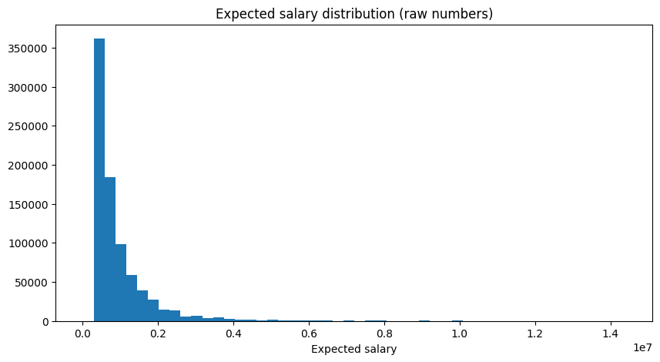
Figure 1: Expected Salary

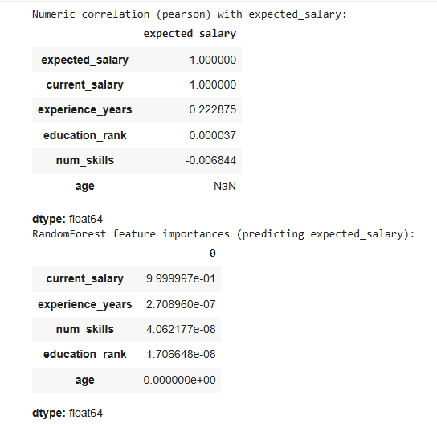
Figure 2 : Numeric Correlation
Interpretation:
This distribution suggests significant heterogeneity in salary expectations among job seekers. While the majority of candidates anticipate moderate compensation levels, a smaller segment expects substantially higher salaries, likely reflecting senior professionals, specialized roles, or aspirational reporting. The observed skewness reinforces the importance of using robust analytical techniques and transformations when modeling salary-related variables.

Work Experience Distribution
Work experience also displayed a skewed distribution, with a median of 0.75 years and a mean of 2.39 years. A large proportion of job seekers fall within the early-career or entry-level category.
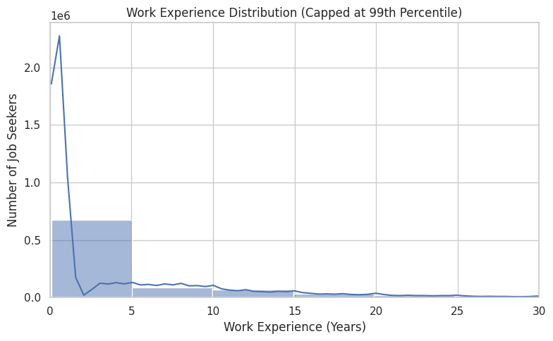
Figure 3 : Work Experience Distribution
Interpretation:
The dominance of candidates with limited experience indicates that the dataset primarily represents a young workforce. This pattern aligns with broader labor market trends characterized by high entry-level participation and frequent job transitions. The prevalence of early-career professionals has implications for salary expectations, skill development, and workforce mobility.

4.5 Correlation Analysis and Preliminary Relationships
To explore relationships among numerical variables, correlation analysis was conducted. The results revealed a near-perfect correlation between current salary and expected salary. This outcome is intuitive, as job seekers often base their expectations on their existing compensation levels.
Work experience exhibited a moderate positive correlation with expected salary, indicating that increased experience is generally associated with higher salary expectations. However, the strength of this relationship was limited, suggesting that experience alone does not fully explain salary variation. Education rank and number of skills demonstrated very weak correlations with expected salary.
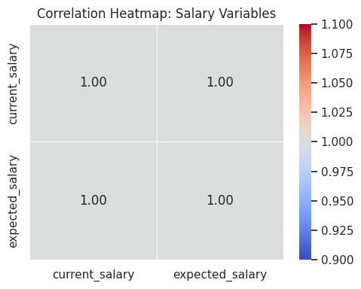
Figure 4 : Correlation Heatmap
Interpretation:
These findings highlight that while experience contributes positively to salary expectations, its influence is modest. The weak correlations with education and skill count suggest that the qualitative aspects of education and skills—such as relevance, specialization, and industry alignment—are more important than their mere presence or quantity.

4.6 Education, Specialization, Skills, and Geographic Insights
Education
Analysis across education categories revealed that most academic qualifications are associated with similar median expected salaries. However, professional degrees such as MBBS and certain specialized categories exhibited higher median expectations.
Interpretation:
This pattern reflects the market valuation of professional and regulated career paths, where specialized credentials translate into higher compensation expectations.

Specialization
Certain niche specializations demonstrated exceptionally high median expected salaries. These specializations are likely associated with limited talent supply and high demand, resulting in elevated compensation expectations.
Interpretation:
Specialization plays a crucial role in salary determination, reinforcing the idea that domain-specific expertise commands a premium in the labor market.

Skills
The most frequently reported skills included sales, marketing, Java, C, and C++. However, skills associated with higher median expected salaries tended to be more specialized or technical in nature.
Interpretation:
While general skills are widely possessed, specialized and high-value skills are more strongly associated with higher salary expectations. This distinction underscores the importance of skill relevance over skill quantity.

Geographic Trends
City-wise analysis revealed substantial variation in expected salaries across locations. Certain cities exhibited higher median salary expectations even after controlling for minimum observation thresholds.
Interpretation:
Geographic disparities in salary expectations reflect differences in cost of living, industry concentration, and local labor market conditions.

4.7 Outlier Detection and Analysis
Outlier detection using the IQR method, z-score method, and Isolation Forest identified a significant number of extreme salary observations. While the exact number varied by method, all approaches confirmed the presence of unusually high expected salaries.
Interpretation:
These outliers likely represent senior professionals, niche roles, or aspirational expectations. Rather than being treated as noise, such observations provide valuable insight into the upper extremes of the labor market. Consequently, they were retained with appropriate transformations to preserve analytical integrity.

4.8 Summary of EDA Insights
The Exploratory Data Analysis phase revealed several important insights. Salary expectations and experience distributions are highly skewed, indicating heterogeneity and inequality within the workforce. Experience shows a positive but limited relationship with salary expectations, while education and skill count alone are weak predictors. Specialization, skill relevance, and geography emerge as more influential factors.
These findings directly inform the subsequent clustering and regression analyses by highlighting the complexity of salary determination and the limitations of traditional predictors. EDA thus provides a robust empirical foundation for deeper analytical investigation.

5. Clustering Analysis
5.1 Objective of Clustering Analysis
Clustering analysis is an unsupervised machine learning technique used to group observations into homogeneous segments based on similarity across selected attributes. In the context of this study, the primary objective of clustering is to identify whether job seekers can be meaningfully segmented into distinct groups based on their professional and compensation-related characteristics. Such segmentation facilitates a deeper understanding of workforce composition and supports targeted recruitment and compensation strategies.
Given the heterogeneity observed during the Exploratory Data Analysis phase—particularly in salary expectations, experience levels, and skill profiles—clustering serves as a logical next step to uncover latent structures within the data. Unlike regression analysis, which focuses on prediction, clustering aims to discover natural groupings without predefined labels. This approach is particularly valuable in labor market analysis, where job seeker profiles may not conform to clearly defined categories.
Specifically, the clustering analysis in this study seeks to address the following objectives:
- To determine whether job seekers form distinct segments based on experience, education, skills, and salary attributes
- To characterize each cluster in terms of its defining features
- To assess the extent to which traditional variables such as experience and education differentiate job seeker profiles
- To provide insights that complement and contextualize the findings from EDA and regression analysis

5.2 Variables Used for Clustering
Based on insights from the EDA phase, a subset of variables was selected for clustering to ensure relevance and analytical effectiveness. The variables included:
- Work Experience (Years): Represents professional maturity and career stage
- Education Rank: Encodes the relative level of educational attainment
- Number of Skills: Captures the breadth of skill exposure
- Log-transformed Expected Salary
- Log-transformed Current Salary
Salary variables were log-transformed to reduce skewness and minimize the influence of extreme values, as identified during EDA. The inclusion of both current and expected salary allows the clustering process to capture compensation alignment and aspiration levels simultaneously.
Prior to clustering, all variables were standardized to ensure equal contribution to distance calculations, as K-Means clustering is sensitive to scale differences among variables.

5.3 Clustering Methodology
The K-Means clustering algorithm was employed due to its computational efficiency and suitability for large datasets. K-Means partitions observations into a predefined number of clusters by minimizing within-cluster variance and maximizing between-cluster separation.
To determine the optimal number of clusters, the Elbow Method was applied. This method involves plotting the total within-cluster sum of squares (WCSS) against different values of K and identifying the point at which additional clusters yield diminishing reductions in WCSS.
The Elbow Curve exhibited a clear inflection point at K = 2, indicating that two clusters provide the most appropriate balance between model simplicity and explanatory value. Consequently, the final clustering model was built using two clusters.

5.4 Clustering Results
The clustering algorithm segmented the job seekers into two distinct clusters. Summary statistics were computed for each cluster to facilitate comparison across key variables.
Key observations from the cluster profiles include:
- Experience: One cluster exhibited a marginally higher median experience level compared to the other.
- Education Rank: Both clusters displayed similar median education ranks, indicating limited differentiation based on education.
- Number of Skills: The average number of skills reported was comparable across clusters.
- Salary Attributes: Median log-transformed expected and current salaries were broadly similar between clusters.
Despite the large dataset size, the differences between clusters were relatively subtle rather than sharply defined.

5.5 Interpretation of Clustering Results
The clustering results indicate that job seekers do not naturally segregate into strongly distinct groups based solely on experience, education, skill count, and salary attributes. While minor differences in experience levels exist, the overall similarity across clusters suggests that these traditional variables are insufficient to create clearly differentiated job seeker segments.
This outcome aligns closely with the findings from the EDA and correlation analysis, which demonstrated weak to moderate relationships between salary expectations and variables such as experience and education. The absence of pronounced cluster separation implies that salary expectations and professional profiles are influenced by additional factors not captured in the selected variables.
Potential unobserved factors include:
- Specific job roles and responsibilities
- Industry-specific wage structures
- Company size and employer brand
- Certifications and specialized training
- Individual negotiation behavior and career aspirations
The similarity between clusters also reflects the dominance of early-career professionals in the dataset, which limits the extent of variability along experience and salary dimensions. As a result, the workforce appears relatively homogeneous when viewed through the lens of conventional demographic variables.

5.6 Managerial and Analytical Implications
From a managerial perspective, the clustering results suggest that simplistic segmentation strategies based solely on experience or education may be ineffective. Recruiters and organizations seeking to differentiate candidates must incorporate richer and more nuanced data, such as role-specific competencies, industry experience, and performance indicators.
From an analytical standpoint, the results highlight the limitations of unsupervised segmentation when key explanatory variables are weakly differentiated. While clustering remains a valuable exploratory tool, its effectiveness depends heavily on variable selection and data richness. The findings reinforce the need to supplement clustering with predictive modeling and domain-specific features.

5.7 Linkage to Regression Analysis
The limited differentiation observed in clustering provides important context for the regression analysis that follows. If job seekers do not form clearly distinct segments based on experience, education, and skills, it is reasonable to expect that these variables may also exhibit limited predictive power in explaining salary expectations. This insight foreshadows the regression results, which demonstrate low explanatory strength for traditional predictors.

5.8 Summary of Clustering Insights
The clustering analysis reveals that while minor segmentation exists within the job seeker population, traditional variables such as experience, education, and skill count do not produce strongly distinct clusters. Salary expectations appear to be shaped by complex and multidimensional factors beyond the scope of basic demographic attributes.
These findings emphasize the importance of incorporating contextual and qualitative variables in workforce analytics and provide a critical bridge between exploratory insights and predictive modeling outcomes.

6. Regression Analysis
6.1 Objective of Regression Analysis
Regression analysis is employed in this study to examine the relationship between expected salary and selected explanatory variables and to assess the extent to which these variables can predict salary expectations. While Exploratory Data Analysis provided descriptive insights and clustering revealed limited natural segmentation, regression analysis enables formal quantification of relationships and evaluation of predictive strength.
The specific objectives of regression analysis in this study are:
- To quantify the impact of work experience, education level, and skill count on expected salary
- To evaluate the explanatory power of these variables using model fit metrics
- To assess the practical usefulness of linear regression models in predicting salary expectations
- To identify limitations of traditional predictors and motivate more advanced modeling approaches
Given the widespread assumption that experience, education, and skills are key drivers of compensation, regression analysis provides an empirical test of these assumptions using large-scale data.
6.2 Model Specification and Variable Selection
Two regression models were estimated in this study: Multiple Linear Regression (MLR) and Simple Linear Regression (SLR).
Dependent Variable
- Expected Salary: The salary level anticipated by the job seeker, expressed in monetary units.
Independent Variables
- Work Experience (Years): Represents professional tenure and career progression.
- Education Rank: Encodes relative educational attainment.
- Number of Skills: Represents the breadth of skills reported by the job seeker.
These variables were selected based on insights from EDA and their theoretical relevance in labor market analysis. While current salary exhibited a near-perfect correlation with expected salary, it was excluded from the regression models to avoid redundancy and to focus on explanatory rather than tautological prediction.
6.3 Multiple Linear Regression (MLR) Results
The Multiple Linear Regression model was estimated using experience years, education rank, and number of skills as predictors.
Model Performance Metrics
- Training R²: 0.049
- Testing R²: 0.050
- Training MAE: ₹530,378.90
- Testing MAE: ₹531,295.52
These results indicate that the model explains approximately 5% of the variance in expected salary.
Estimated Regression Equation
$$\text{Expected Salary}=820,975.58+(29,201.73×\text{Experience})+(283.23×\text{Education Rank})-(1,813.13×\text{Number of Skills})$$
6.4 Interpretation of MLR Coefficients
The coefficient for work experience is positive and statistically meaningful in magnitude, indicating that expected salary increases by approximately ₹29,200 for each additional year of experience, holding other variables constant. This result aligns with economic theory and labor market intuition, as experience generally enhances productivity and bargaining power.
The coefficient for education rank is positive but relatively small, suggesting that higher educational attainment is associated with marginally higher salary expectations. However, the limited magnitude of this coefficient implies that education alone does not substantially differentiate salary expectations when analyzed at scale.
The coefficient for number of skills is negative, which may initially appear counterintuitive. However, this result suggests that simply listing a larger number of skills does not necessarily translate into higher salary expectations. It indicates that skill relevance and specialization, rather than skill quantity, are more important determinants of compensation.
The intercept represents the baseline expected salary when all predictors are zero. While not directly interpretable in practical terms, it provides a reference point for the model.
6.5 Model Fit and Predictive Performance
The low R² values observed in both training and testing datasets indicate that the selected predictors explain only a small fraction of salary variation. Additionally, the high Mean Absolute Error—exceeding ₹530,000—suggests that the model’s predictions deviate substantially from actual salary expectations on average.
Interpretation:
These results demonstrate that traditional predictors such as experience, education, and skill count are insufficient to accurately predict expected salary in isolation. Salary expectations are influenced by complex and often qualitative factors that are not captured by these variables.
The consistency between training and testing performance suggests that the model is not overfitting; rather, it reflects genuine limitations in explanatory power.
6.6 Simple Linear Regression (SLR) Results
To further isolate the effect of experience, a Simple Linear Regression model was estimated using experience years as the sole predictor.
Estimated Equation
$$\text{Expected Salary}=803,720.88+(27,524.19×\text{Experience})$$
Interpretation
The positive slope confirms that experience has a direct and positive relationship with expected salary. Each additional year of experience is associated with an increase of approximately ₹27,500 in expected salary. However, the explanatory power of this model remains limited, reinforcing the conclusion that experience alone cannot account for the wide dispersion observed in salary expectations.
6.7 Comparison of MLR and SLR Models
Comparing the two models reveals that adding education and skill count to experience provides only marginal improvement in explanatory power. Both models exhibit low R² values and high prediction errors, highlighting the inherent complexity of salary determination.
This comparison underscores an important analytical insight: the inclusion of additional variables does not guarantee improved model performance unless those variables capture meaningful variation relevant to the outcome.
6.8 Limitations of Regression Analysis
Several limitations of the regression models should be acknowledged. First, the models assume linear relationships, which may not adequately represent the true nature of salary determination. Second, key explanatory variables such as job role, industry-specific wage structures, company size, certifications, and negotiation behavior were not included due to data limitations. Third, salary expectations may reflect aspirational rather than market-aligned values, introducing additional noise into the dependent variable.
6.9 Managerial Implications and Recommendations
The regression results have important practical implications. Organizations should avoid over-reliance on experience or education as sole indicators of salary expectations. Instead, recruitment and compensation strategies should emphasize role-specific competencies, industry context, and demonstrated expertise. From an analytical perspective, future studies should explore non-linear models and incorporate richer contextual variables to improve predictive accuracy.
6.10 Summary of Regression Insights
The regression analysis demonstrates that while experience positively influences salary expectations, its impact is limited. Education and skill count contribute minimally, and overall model performance is weak. These findings reinforce the conclusion that salary expectations are shaped by multidimensional and contextual factors beyond traditional demographic attributes.

7. Conclusion
This Business Analytics study set out to examine job seeker behavior and salary expectations using a large-scale dataset comprising over 913,000 observations. By systematically applying Exploratory Data Analysis, clustering techniques, and regression modeling, the study aimed to identify key determinants of expected salary, assess the feasibility of segmenting job seekers into meaningful groups, and evaluate the predictive power of commonly assumed salary drivers such as experience, education, and skills.
The Exploratory Data Analysis revealed substantial heterogeneity within the job seeker population. Salary expectations were found to be highly right-skewed, indicating significant inequality across the workforce. While most job seekers reported moderate salary expectations, a smaller proportion exhibited exceptionally high expectations, contributing to a wide dispersion in salary values. Experience distribution further highlighted the dominance of early-career professionals, suggesting a young and mobile workforce. Correlation analysis demonstrated that current salary is the strongest anchor for expected salary, while experience shows only a moderate relationship. Education level and skill count exhibited weak associations, emphasizing the limitations of simplistic assumptions regarding compensation determinants.
The Clustering Analysis provided additional insights into workforce segmentation. Despite the large dataset and inclusion of multiple relevant variables, only two clusters emerged, with limited differentiation across experience, education, skills, and salary attributes. This outcome suggests that job seekers do not naturally segregate into sharply defined groups based on traditional demographic and professional variables alone. Instead, salary expectations and professional profiles appear to be shaped by more nuanced and context-specific factors that are not directly captured in the dataset, such as job role specificity, industry wage structures, and employer characteristics.
The Regression Analysis further reinforced these findings. Both multiple and simple linear regression models exhibited low explanatory power, with experience, education, and skill count collectively explaining only a small proportion of the variance in expected salary. While experience demonstrated a positive relationship with salary expectations, its impact was modest. The weak predictive performance of the models highlights the complexity of salary determination and underscores the limitations of linear models when applied to heterogeneous labor market data.
Overall, the study demonstrates that salary expectations are influenced by a multidimensional set of factors, many of which extend beyond conventional indicators such as experience and education. The findings underscore the importance of incorporating richer, context-specific variables and advanced analytical techniques to achieve a more accurate understanding of compensation dynamics.
Key Takeaways
- Salary expectations among job seekers exhibit significant inequality and high dispersion.
- Work experience positively influences expected salary, but its explanatory power is limited.
- Education level and skill count alone are weak predictors of salary expectations.
- Job seekers do not form strongly differentiated clusters based on traditional attributes.
- Workforce mobility is high, indicating flexible location preferences.
- Salary determination is shaped by complex, contextual factors beyond basic demographics.
- Advanced, non-linear models and richer datasets are required for effective salary prediction.

